**DFD level 2:**

**Process 1 – Login:**

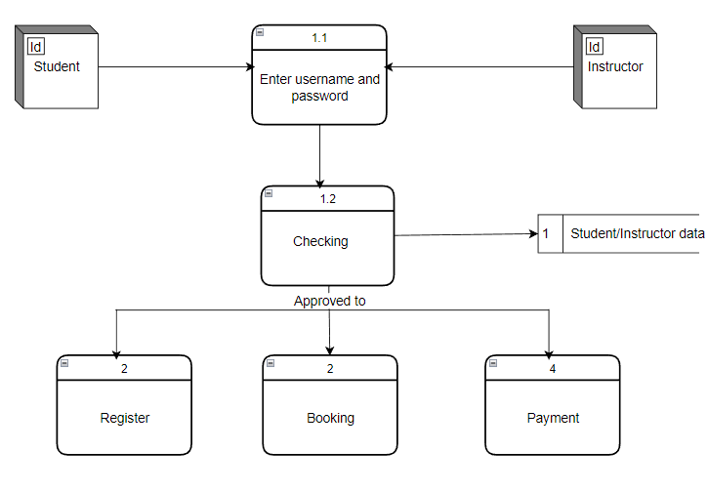

**Process 2 – Registration:**

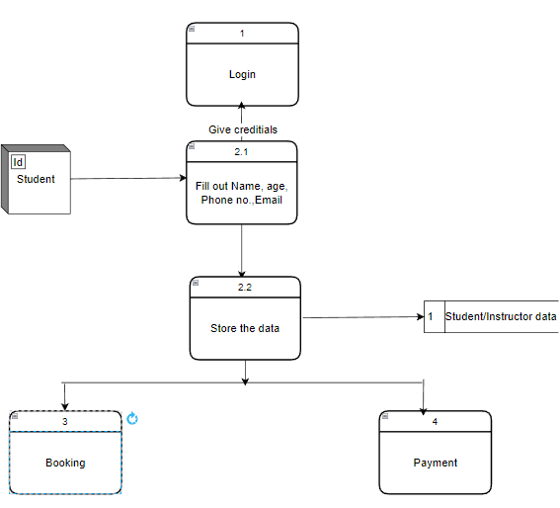

**Process 3-Booking:**

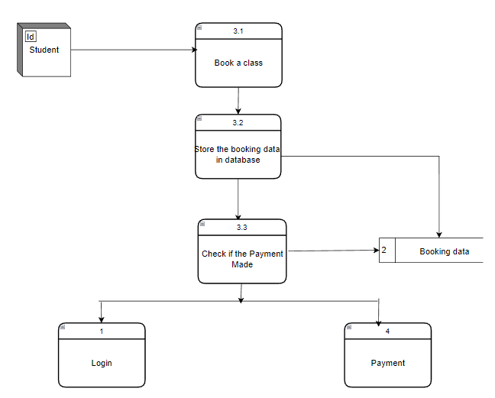

**Process 4-Payment:**

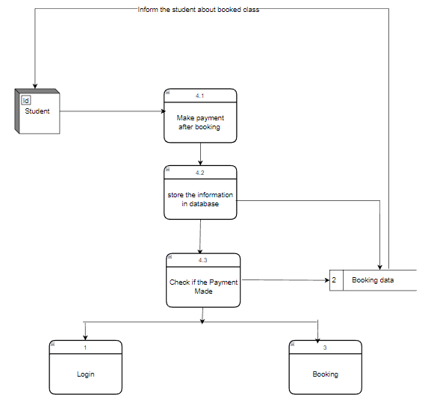

**Process 5-Manage class Schedule:**

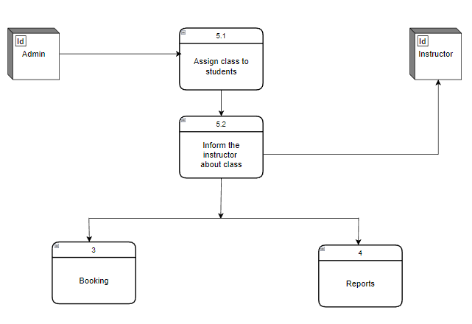

**Process 6-Reports:**

